Name: Joseph A. Merrill
Date: 18 JAN 2026
Week 2 - Create an Analysis Model for a Small Bed & Breakfast Reservation System

1) Rubric Criteria: Create UML use case diagram of 3-7 use cases 10%
Your Response:
Primary Actor: B&B Owner (John or Jane – sole system users)
Identified Use Cases (6 total): Check Room Availability, Create Reservation, Guarantee Reservation, Modify Reservation, Cancel Reservation, Generate Reports
These use cases represent high-level system goals rather than implementation details, which aligns with UML use-case modeling standards and the assignment requirements

2) Rubric Criteria: Write use case sequence of events for each use case in the use case diagram 20%
Your Response:
Use Case 1: Check Room Availability
Actor: B&B Owner
Goal: Determine which rooms are available for a given date range
Precondition: System is operational
Postcondition: Availability information is displayed
Sequence of Events:
Owner requests availability for a specified date range
System evaluates room schedules for that period
System presents available and unavailable rooms

Use Case 2: Create Reservation
Actor: B&B Owner
Goal: Record a new reservation for a guest
Precondition: Room availability is known
Postcondition: Reservation exists in the system
Sequence of Events:
Owner provides guest information.
Owner selects room and reservation dates.
System creates a reservation and assigns an initial status

Use Case 3: Guarantee Reservation
Actor: B&B Owner
Goal: Secure a reservation through payment
Precondition: Reservation exists
Postcondition: Reservation is guaranteed
Sequence of Events:
Owner initiates guarantee for a reservation
System records payment details
System updates reservation status to guaranteed

Use Case 4: Modify Reservation
Actor: B&B Owner
Goal: Change an existing reservation
Precondition: Reservation exists
Postcondition: Reservation is updated
Sequence of Events:
Owner selects a reservation
Owner requests changes
System validates and applies updates

Use Case 5: Cancel Reservation
Actor: B&B Owner
Goal: Remove an existing reservation
Precondition: Reservation exists
Postcondition: Reservation is canceled
Sequence of Events:
Owner selects a reservation to cancel
System removes the reservation and updates availability

Use Case 6: Generate Reports
Actor: B&B Owner
Goal: View operational and financial summaries
Precondition: Data exists
Postcondition: Report is output
Sequence of Events:
Owner requests a report type
Owner specifies a date range
System compiles relevant reservation and payment data
System presents the report to the owner

3) Rubric Criteria: Explain approach, steps, and rationale of the use case model 25%
Your Response:

Approach: A user-centric, goal-oriented approach was used to identify system behavior. Because the B&B owners are the only users, a single actor was modeled to reduce complexity while fully capturing system functionality.
Steps:
Identify external actors interacting with the system
Identify business goals the system must support
Define use cases that encapsulate each goal
Describe each use case using goal-focused sequences
Rationale: This approach ensures traceability from requirements to design and testing. Each use case directly maps to a functional requirement, reducing ambiguity and supporting later verification and validation activities.

4) Rubric Criteria: Create UML class diagram 10%
Your Response:
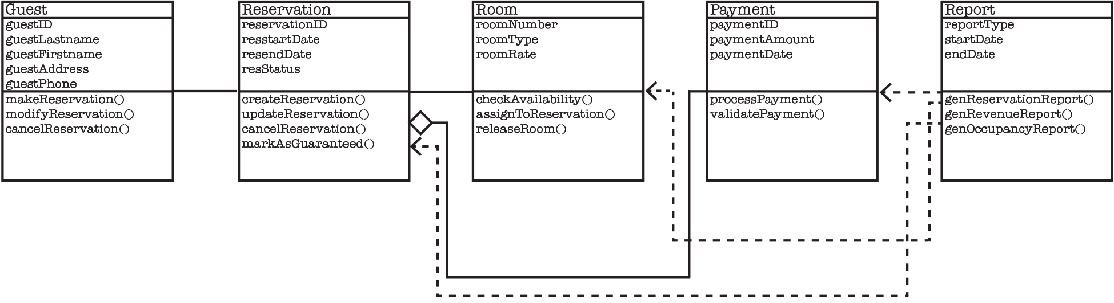
Class: Guest
Attributes: guestID, guestLastname, guestFirstname, guestAddress, guestPhone
Methods: makeReservation(), modifyReservation(), cancelReservation()

Class: Room
Attributes: roomNumber, roomType, roomRate
Methods: checkAvailability(), assignToReservation(), releaseRoom()

Class: Reservation
Attributes: reservationID, resstartDate, resendDate, resStatus
Methods: createReservation(), updateReservation(), cancelReservation(), markAsGuaranteed()

Class: Payment
Attributes: paymentID, paymentamount, paymentDate
Methods: processPayment(), validatePayment()

Class: Report
Attributes: reportType, startDate, endDate
Methods: generateReservationReport(), generateRevenueReport(), generateOccupancyReport()

Relationships:
Guest → Reservation
A Guest makes reservations but does not own them as parts.
Arrow type: Association
Symbol: Solid line

Room → Reservation
Rooms are assigned to reservations, but neither class is a subtype or owned object.
Arrow type: Association
Symbol: Solid line

Reservation → Payment
A Reservation has a Payment, but a Payment can exist independently (refunds, records).
Arrow type: Aggregation
Symbol: Solid line with open diamond at Reservation

Report → Reservation
Reports read reservation data but do not own or store it.
Arrow type: Dependency
Symbol: Dashed line with arrow toward Reservation

Report → Payment
Reports read payment data but do not own or store it.
Arrow type: Dependency
Symbol: Dashed line with arrow toward Payment

Report → Room
Reports read room data but do not own or store it.
Arrow type: Dependency
Symbol: Dashed line with arrow toward Room

5) Rubric Criteria: Explain approach, steps, and rationale of the class diagram model 25%
Your Response:

Classes were derived using noun analysis from the problem statement and use case descriptions.

Steps:
Extract domain nouns from requirements, group related attributes into cohesive classes, and define associations and multiplicities based on real-world rules.

Rationale:
This model accurately reflects the business domain while remaining simple and extensible. It supports all identified use cases and establishes a clean foundation for the design phase.

6) Rubric Criteria: Reflect on the learning experience and lessons learned 10%
Your Response:

This assignment highlighted how critical analysis modeling is before any design or coding begins. Developing use cases clarified system behavior from the user’s perspective, while the class diagram translated those behaviors into structured data relationships. A key lesson learned is that clear, goal-oriented use cases make later design decisions significantly easier. By separating what the system must do from how it will do it, the analysis model reduces risk and improves software quality.

